**OUTPUT**

|  |  |
| --- | --- |
| Team ID | PNT2022TMID32929 |
| Project Name | Project - Personal Expense Tracker Application |

**Home**

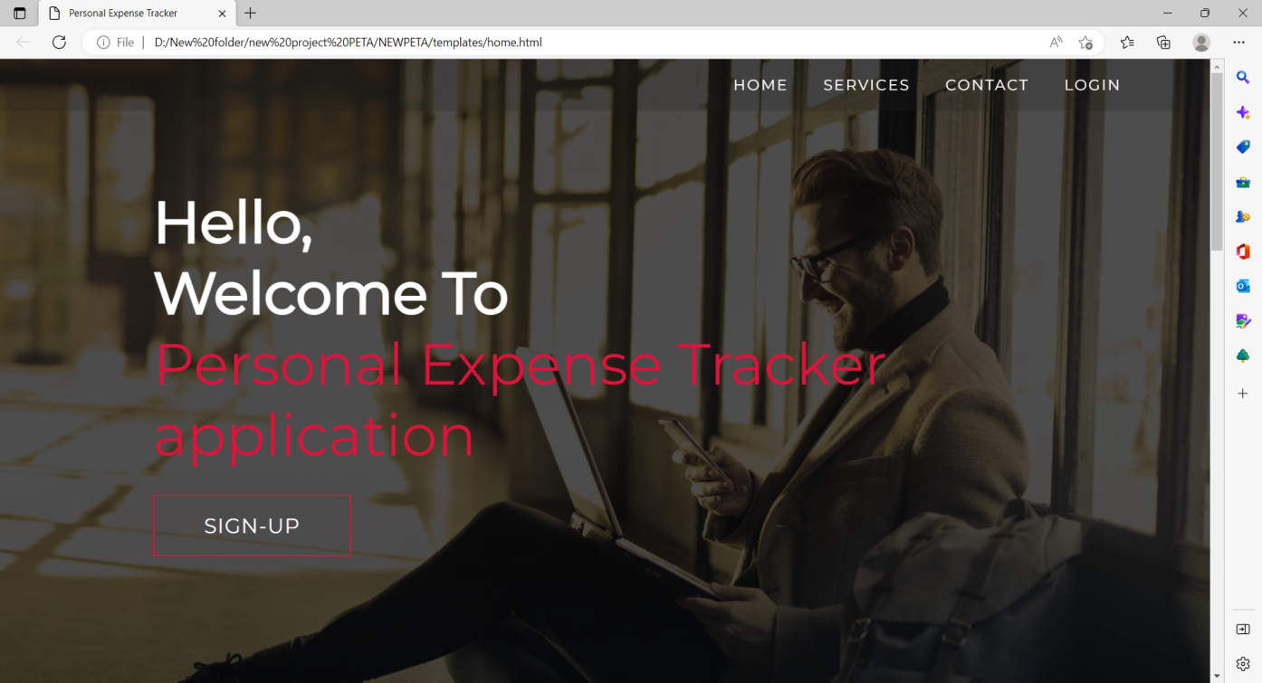

**Home-Services**

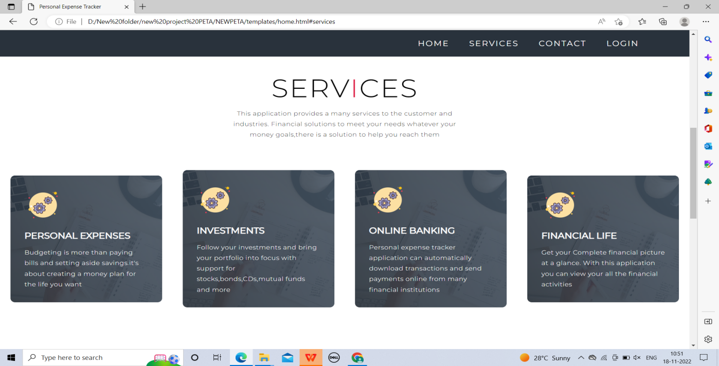

**Home-Contacts**

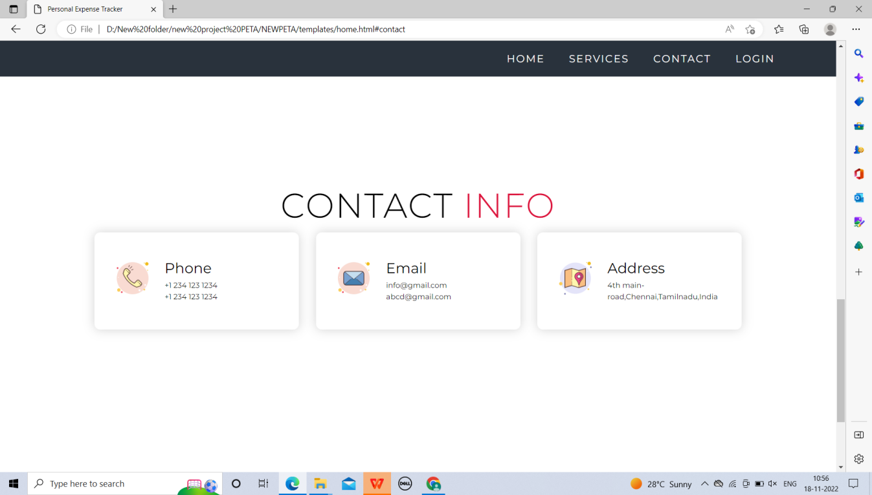

**Login**

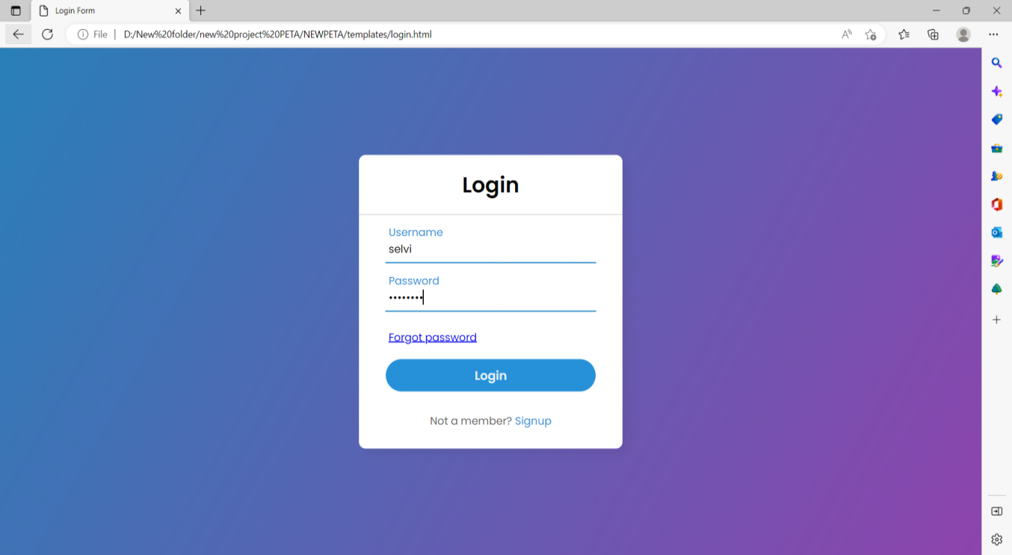

**Registration**

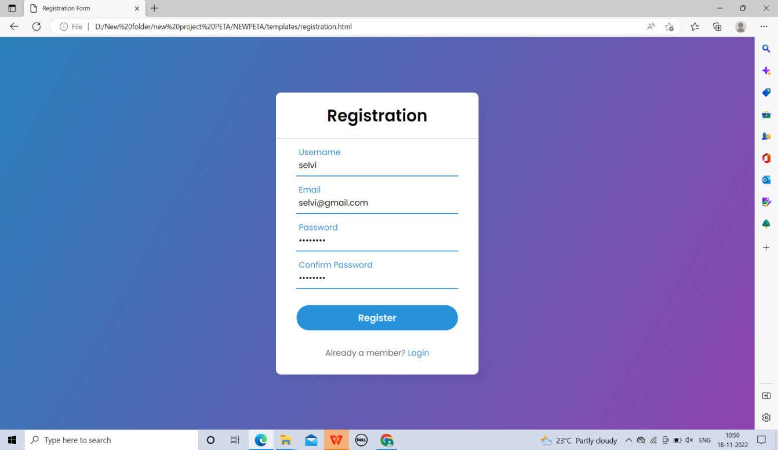

**Dashboard**



**Add Expense**

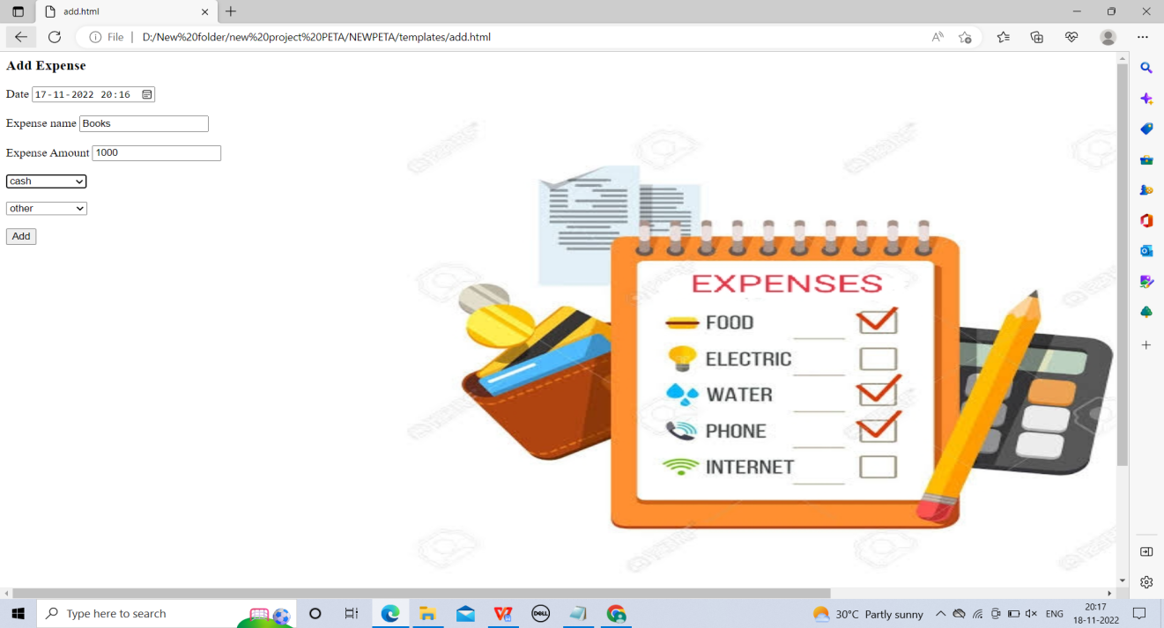

**Limit**

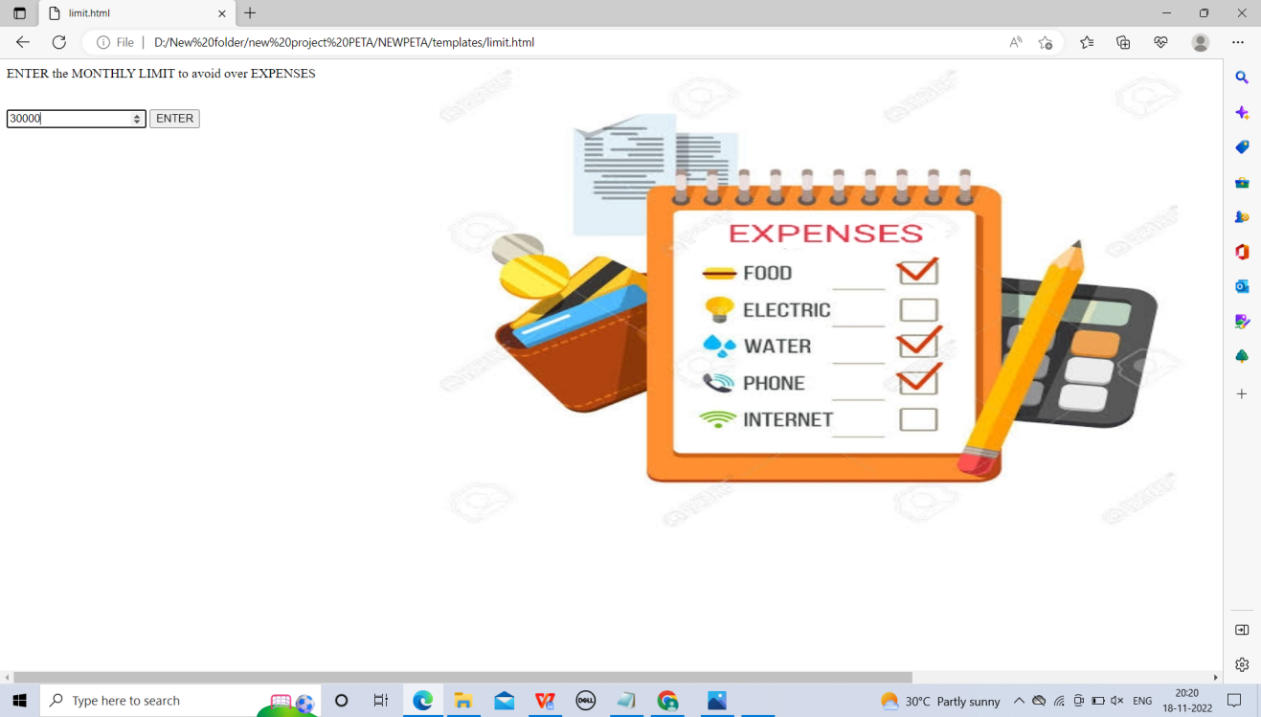

**Report**

